Role Profile

 | Role Title | Product Design and Development Apprentice
 | Business group and team | Digital & Innovation Office – Innovation & Development Lab
 | Job Purpose Overview | A Product Design and Development Apprentice within The Innovation and Development Team at Hanslope Park is largely expected to work under direct supervision of qualified Workshop Technicians and/or Workshop Managers. Under instruction, they will be expected to apply proven techniques and procedures to support the design, prototyping testing and development of physical products that secure Government assets at home and overseas.  Product Design and Development Apprentices will work flexibly and collaboratively with the wider Innovation and Development team to develop the next generation of physical FCDO Services Products. Product Design and Development Apprentices may be deployed in other design and production environments depending on workload to develop wider skills/knowledge/experience (System design, Metal workshop, Wood workshop, Training school, Locks) so that they can both assist with the production/assembly of products in other workshops, when peaks in demand are experienced and gain a full understanding of the prototype and production processes used by FCDO Services.  This UK based role is line managed by the Innovation and Development Lab Manager.
 | Organisational position | Insert organisational chart or give brief description of where the role sits in the organisation. (To comply with our security rules, only provide the name of the job).
 |  | 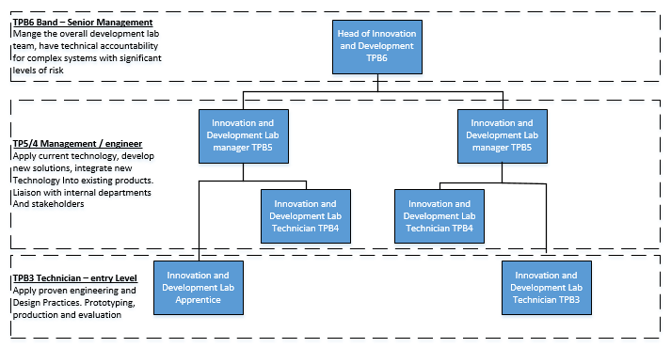
 | Date Updated | 03/02/21 |  |  |  | Updated By |  | S Edwards
 | Current / Applied Grade | Apprentice |  |  | Job evaluation date |  |  | Confirmed grade
 | Level of Security Clearance | SC  DV | Yes  Yes
 | Job RESponsibilities
Main responsibilities, focusing on the required outputs:

People
- Undertake specific training on all lab and relevant design workshop equipment, with all relevant H&S training as required. (Software design, electrical and manufacturing equipment)
- Maintain own professional development and expertise of the latest electronic and engineering technologies, following best practice to support and grow the business.
- Maintain a comprehensive training record, ensuring relevant refresh training is highlighted in advance.
- Develop technical skills outside own area of expertise that would benefit FCDO Services.
- Actively participate in the Task Assessment and Performance Development Review process through giving and receiving feedback.
- Communicating effectively with colleagues, customers and stakeholders both verbally and in written reports or emails.

Customer
- Work in partnership with stakeholders to document and deliver solutions to meet their needs, to agreed standards, on time and within budget.
- Work with stakeholders and customers to identify their requirements and ensure what is developed meets their needs
- Liaise with the customer to ensure products are delivered to agreed time, cost and quality.
- Develop/maintain relationships across FCDO Services to help with the timely delivery of products.
- Know how the role contributes to the overall achievement of FCDO Services' Business Plan.

Financial
- Work effectively as part of a team (which may include both FCDO Services staff and contractors) in carrying out the development of FCDO Services’ products to meet our customer’s needs, contributing to delivery on time and within budget.
- For H&S/efficiency maintain a clean tidy workshop environment and follow safe working practices.
- Assisting with the research and development into potential future products and services.
- Timely allocation and recording of expenditure against correct project codes.
- Update task/project documentation.

Operational Delivery
- Work under supervision to apply proven techniques and procedures to the solution of practical engineering problems as directed by Development Lab Managers and Workshop Technicians.
- Comply with all relevant risk assessments and safe systems of work.
- Ensure H&S policies are adhered to and implemented.
- Comply with H&S policy & procedures set by FCDO Services & HSE including, but not limited to; the reporting and recording of faults/accidents/incidents/near misses.
- Assist with planned and preventative development lab equipment upgrades and maintenance.
- Assist with and work within the ISO 9001 Quality Assurance process.
- Ensure personal adherence to all FCDO Services corporate processes.
Knowledge and Key Skills
Essential:
- Hold a minimum of 4 GSCEs (or equivalent e.g. O Levels) grade 9 – 4 (A* - C) including Maths, English and Science (preferably Physics), or equivalent or a technical based subject such as engineering or product design.
- Evidence of previous design / production / electronics / relevant practical examples from school/college projects or hobbies
- Evidence of use of CAD, CAM, 3D printing or computer modelling, relevant practical examples from school/college projects or hobbies
- Evidence of good teamwork or other team based experience or hobbies which involve teamwork.
- Evidence of previous experience in Science, Maths or Engineering.
Desirable:
• Interest or experience in 3D modelling and printing.
• Interest or experience of CAD design.
• Interest in range of IT and networking skills and tools.
• Interest in PCB production / assembly and circuit design.
• Good working knowledge of Microsoft Office packages (Outlook, Word and Excel).

Core Behaviours
Top three for job:
• Commercial Awareness
• Managing a Quality Service
• Delivering at Pace

Critical Success Factors
Success measured and evidenced by:
• Operational work carried out to professional standard and meeting customer requirements.
• FCDO Services internal procedures followed (i.e. H&S, time recording).
• Able to deliver results by managing their time and resources effectively.
• Responding flexibly to changing priorities and meeting objectives.
• Delivery of products on time and within budget.
• Delivery of services in line with requirements.
• Professionalism of work as judged by internal management.
• Technical and other certificates (appropriate for role) up to date.

Budget Responsibility?  N |  |  |  | If YES, how much:  £  per annum |  |  | If NO can they authorise payments?  N
Reports to:  (Role Title and Grade) |  |  |  | Workshop Manager TPB5
Direct Reports:  (Number and grades of staff) |  |  |  | None

